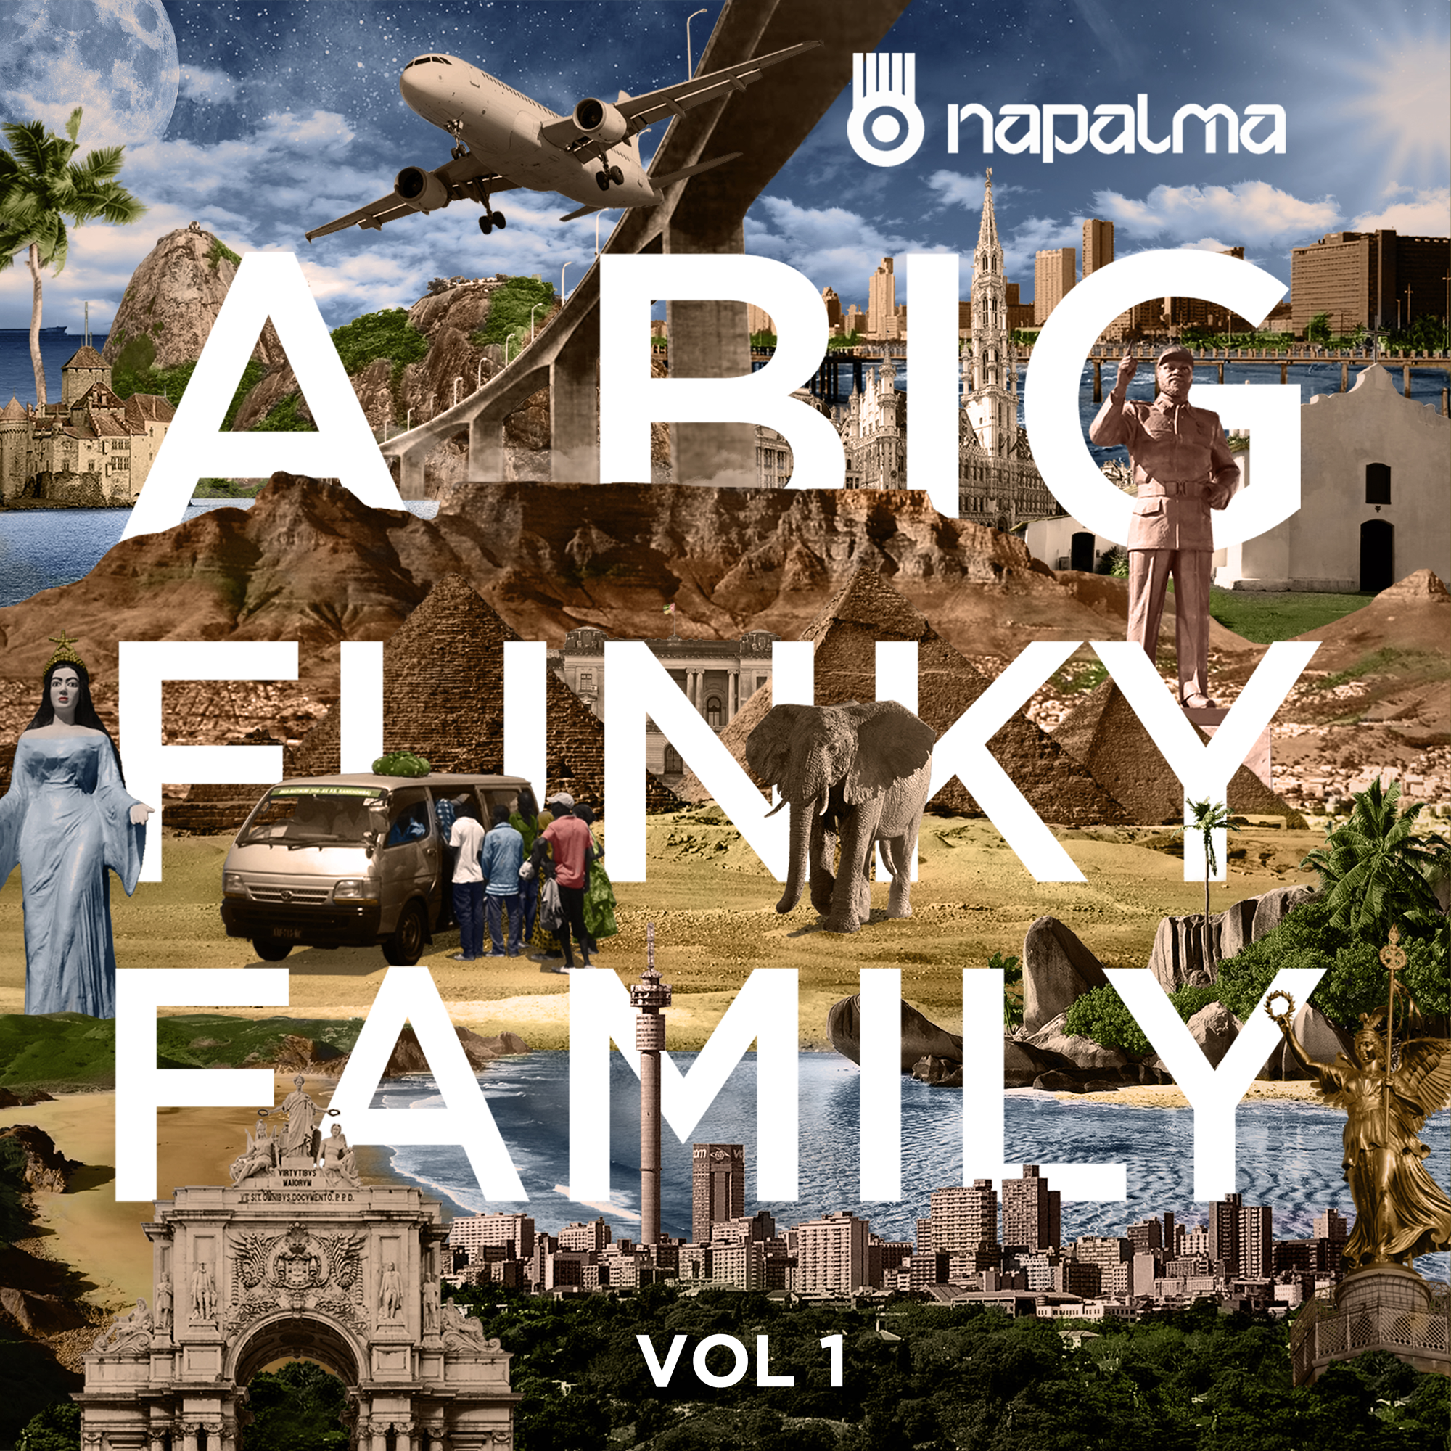
Napalma
‘A Big Funky Family – Vol1’
We are proud to announce to you our new release!

‘A Big Funky Family – Vol1’ is the first of a serie of 3 volumes, each containing six songs created along many collaborators, music producers, singers and musicians around the world. The songs were crafted in Australia, Mozambique, South Africa, France, Brazil, Egypt and were all glued together by the music producer Marcel Dadalto in Berlin.

‘A Big Funky Family – Vol1’ will be launched worldwide on march 30 on iTunes, Spotify, Napster, Deezer, Amazon, Google Play and Bandcamp. Also the fans will be able to buy a Music Download Card at the shows and then retrieve the songs on the band’s website.

This new release brings new sounds and spices to NAPALMA, adding a catchy electronic arrangement on its massive tunes, heavily influenced by the music experiences throughout several years touring around Africa, South America and Europe.

NAPALMA’s ‘A Big Funky Family Tour' started on the 30th of march at Splashy Fen Festival in South Africa and continues to Pretoria, Namíbia, Durban, Johannesburg, Egypt, Germany, Switzerland, Portugal. More dates to be announced soon.

Please have a listening on ‘A Big Funky Family – Vol1’

Thanks for your attention. We hope you like it.
‘A Big Funky Family - Vol1’
Music Producers & Artists Collaborators:
Australia:
Mista Monk (producer, vocal and electronics in ‘Coast’)
Brazil:
Rafael Jabah (producer, electronics in ‘Sometimes’),
André Nassur (guitar in ‘Sometimes’)
Paulo Bolzan (Art Design)
Egypt:
Said El Housani (Mizmar in ‘Gispy Arabian Nights’)
Nour Ashour (Mizmar production in ‘Gispy Arabian Nights’)
Peter Ayman (sound engineer in ‘Gispy Arabian Nights’)
France:
Infrared (producer and electronics in ‘Love’)
Germany:
Sanny Lys (Vocal in ‘Urban Art’)
Marcel Dadalto (music producer and electronics in all songs)
Rodrigo Cobra (Mastering)
Mozambique:
Muzila Malembe (saxophone in ‘Save Me’),
Drdread Ras TM (producer and electronics in ‘Save Me’),
Filipe Soeiro (producer in ‘Sometimes’)
Portugal:
Milton Gulli (guitar, bass in ‘Coast’)
South Africa:
Lu Chase (vocal in ‘Love’)
Teba Shumba (vocal in ‘Sometimes’)

NAPALMA is:

Ivo Maia: Vocal, Percussion
Cid Travaglia: Percussion, Electronic Programming

‘A Big Funky Family - Vol1’
Credits:
Executive Producer: Cid Travaglia
Artistic Producer: Cid Travaglia
Music Producer: Marcel Dadalto
Mastering: Gondwana Mastering - Rodrigo Cobra
Graphic Design: Paulo Bolzan

www.napalma.com.br

